Now I'll get started carving a cowboy boot. For this project I like to use a wood that is easy to carve but that will not split or break easily. Basswood satisfies both requirements. However my favorite wood for this project is cedar. It looks really nice when finished. Pine or poplar also makes a good job. I'll be using basswood to demonstrate how I carve this and then at the end I'll show you what the basswood boot looks like as well as a cedar boot that I'll be carving at the same time.
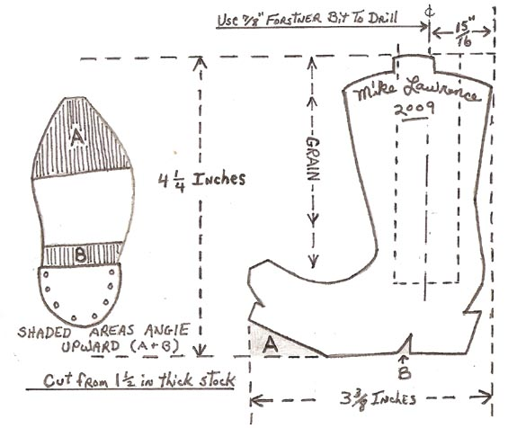
This boot will be 4 1/4 inches high, 3 3/8 inches long (heel to toe) and 1 1/2 inches wide. I'll use the pattern above to cut a blank from a piece of wood this size. I use my computer and printer to resize the pattern to these dimensions. Sometimes I take the pattern to a copy machine and resize patterns to the appropriate size.
Thinking Things Through
I'm starting with a basswood block 4 1/4 inches high X 3 3/8 inches long X 1 1/2 inches thick. I can make this boot to just sit on a shelf to look at, in which case I won't need to drill the 7/8ths inch hole. However I like for my carvings to be somewhat functional when I can. So I'll make this a functional boot by using it for either a toothpick holder or a match holder. I will need to know what I am putting in the holder so that I know how deep to drill the hole. Otherwise if I drill it too deep the item could fall down inside and be out of sight. I like to have them sticking up out the top by at least a half inch. This one will be a match stick holder. It will look nice sitting on the mantle above my fire place. Then when I need to light a fire, I'll have matches handy.
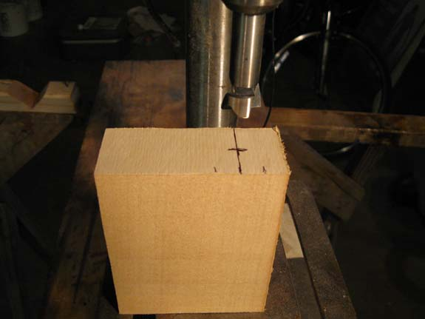
"Drilling the Hole"
I'll want to drill that 7/8th inch hole with my Forstner bit first before I start sawing out the shape of the boot. So while I still have nothing but a squared off block of wood I'll mark and drill the hole. I will make sure that the grain of the wood runs from top to botton (not heel to toe). I will be drilling the 7/8th inch hole with the grain. I'm going to measure along the 3 3/8th inch length of the block and make a mark 15/16th of an inch from one end and center it across the 1 1/2 inch width of the block. I'll secure the block in a vice and drill the hole to the approperiate depth but no deeper than 3 1/4 inch.
May 5, 2009
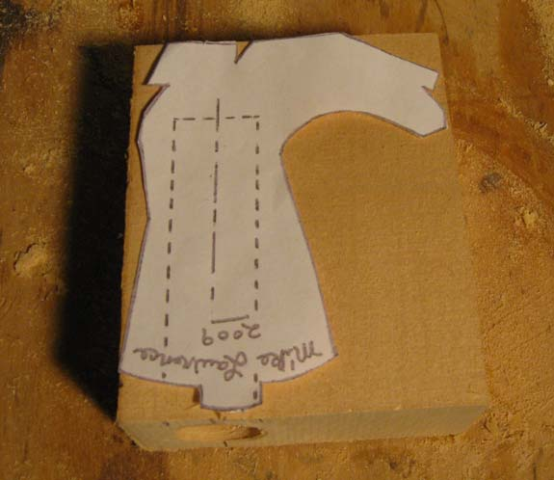
"Tracing the Pattern Onto The Block of Wood"
Now that I have my hole drilled, I'll lay the pattern on the block of wood with a piece of carbon paper under it and trace around the perimeter of the side view of the boot. An option is to cut around the outline of the boot with a pair of sissors and lay the cut out on the piece of wood, then trace around it with a pencil. I must make sure that the shaft of the boot lines up with the hole I drilled or this just won't work out.
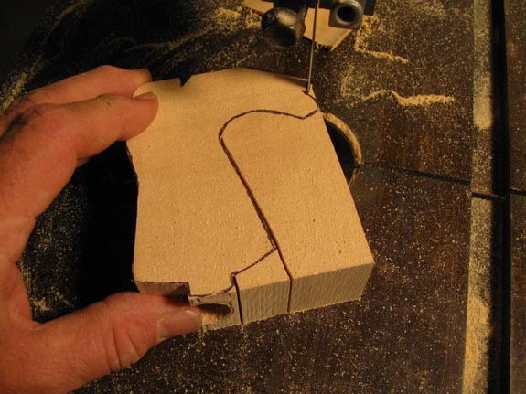
"Sawing Out The Boot Blank"
Next I'll use my bandsaw to saw around the lines I have drawn making sure that I saw just on the outside edge of the line. When I'm done sawing this out, if I can still see most of the pencil marks that's extra good. I don't want to saw past my marks because the hole I drilled is going to be fairly close to outside walls of the finished cut out. This is important because later when I start carving I don't want to carve into the hole. But never fear, all is not lost even if this happens. Have you ever seen a worn out boot with a hole worn through!
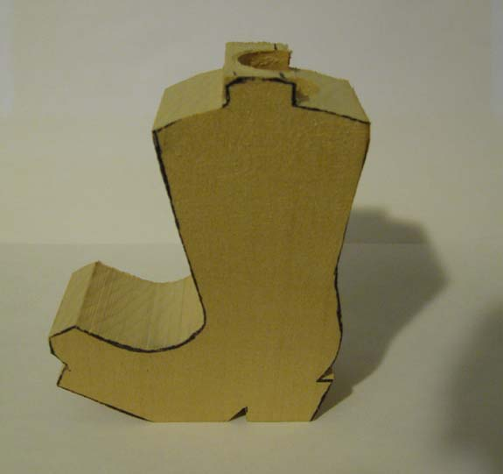
"The Completed Blank"
This is what my completed blank looks like. You might have looked at these photos and thought, "That hole in top of the boot is off center." You would be right that it is off center at the very top of the shaft. However it is on center where it matters and that is at the narrowest point which would be further down just above the heel. Don't worry about the top which appears to be off center. You see why later when I start carving!
May 6, 2009
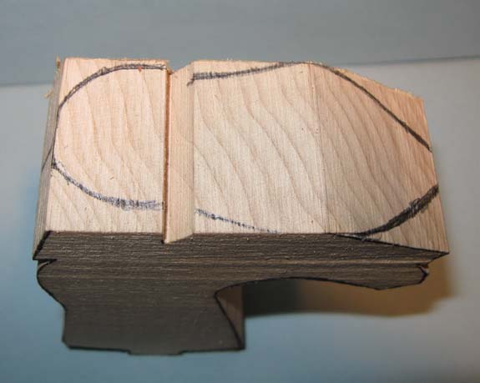
"Laying out the Sole"
I have cut out the pattern of the bottom of the boot and laid it on the bottom of the blank. I trace around the pattern and I now have the outline of how the bottom of the boot will be shaped.
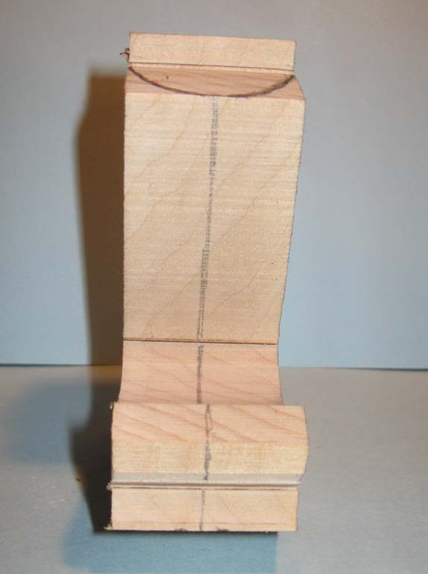
"Drawing the Centerline
Next, I draw a center line up the front and back of the boot. Looking at the bottom of the blank, the center line should intersect with the middle of the toe at the front and the middle of the heel at the back.
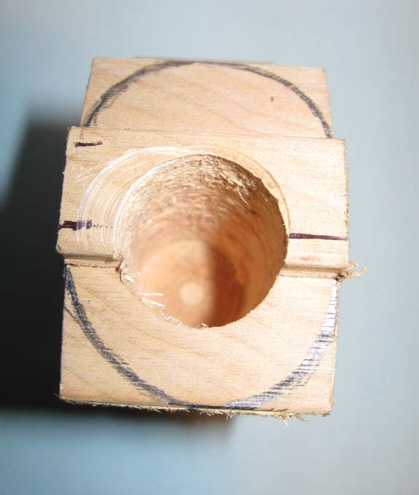
"Laying Out The Top
Lastly I'll draw an oval around the top of the blank. The oval will incircle the previously drilled hole. This will represent the outside edges of the shaft of the boot.
May 7, 2009
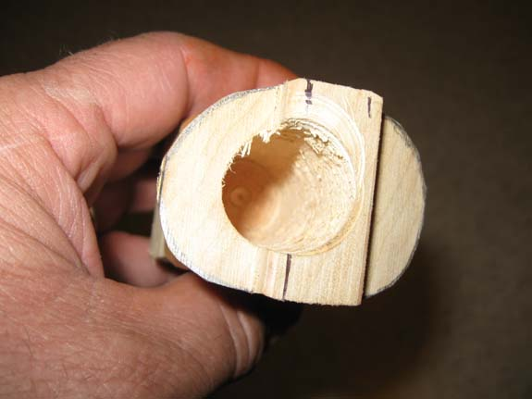
"Carving Around The Top
I will next carve around the top of the shaft up to the line I drew.
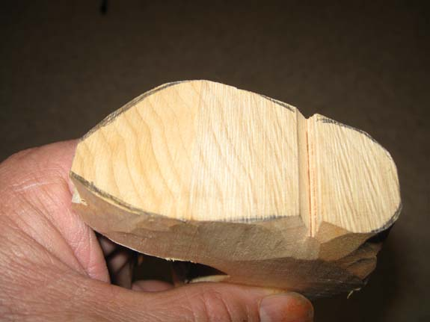
"Carving Around The Sole
Next I carve around the sole up to the line I drew.
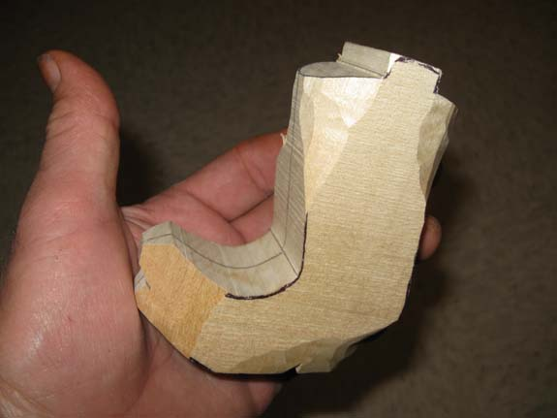
"Planning The Next Cuts
You can see that with the carving done around the top and around the bottom, I still have harsh corners between these two cuttings. The next thing to do is to start joining the top cuts with the bottom cuts by rounding out the shank of the boot and rounding the top of the toe.

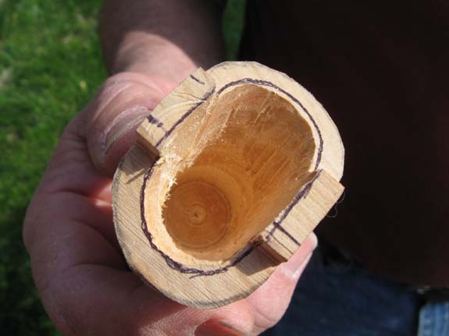
"Opening Up The Hole/Inside of the Boot"
Here you can see that I have drawn another oval inside the first oval and have opened up the hole with my knife that I had originally drilled. The distance between the two ovals is about 3/16ths inch which will leave the walls of the shaft at that thickness.
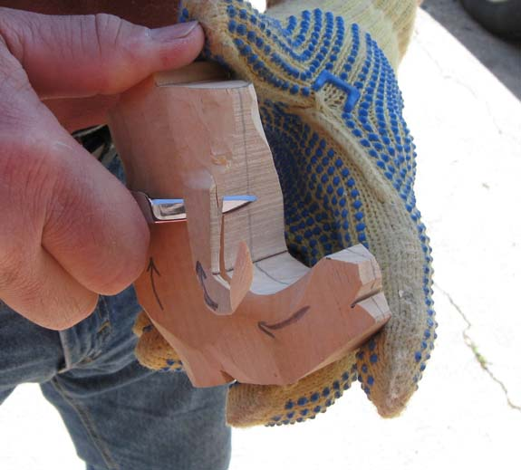
"Rounding Out"
I have drawn arrows showing the direction that I intend to carve. I will round out all the corners and blend everything together. I leave the center lines on the front and back of the boot and do not touch them with the knife. After everything else is carved I will just barely nick the marks off with my knife leaving no sawmarks whatsoever. I blend the top cuts and bottom cuts together and cut away everything thats not a boot.
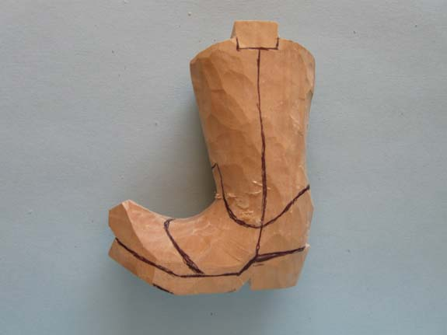
"Marking up for the V-Tool"
Here the final shape of the boot is carved. You will see some splinters and roughness that I don't worry about at this point. I have drawn some lines which denote seams in the leather and creases between the heel/sole and the upper part of the boot.
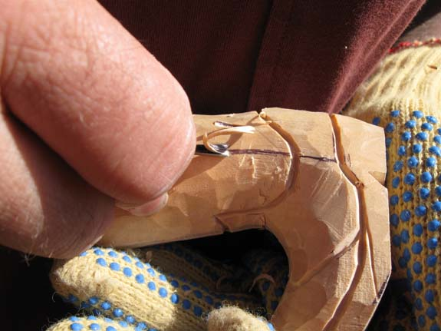
"Using the V-Tool"
Here I have started using the V-tool. I will make a cut on every mark I made. When I get done the marks will be replaced by a fairly clean V-tool cut!
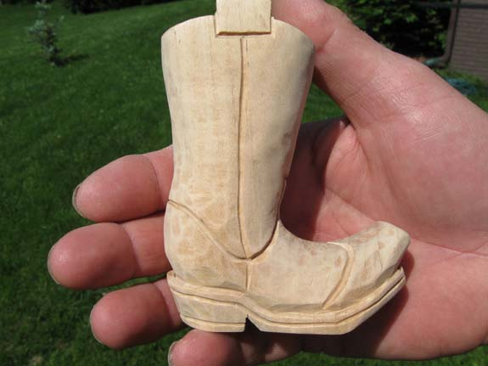
"The Completed V-tool Cuts"
All the V-tool cuts have been made. I added a couple of cuts on the sole and heel to indicate layers of leather. I have also done some light sanding. I'll sand a little more later.
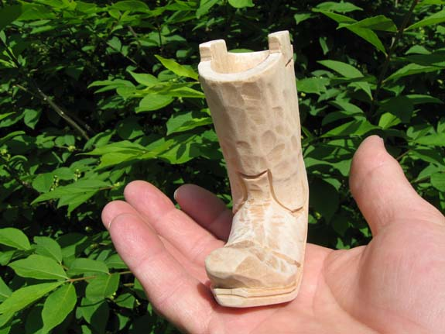
"The Completed V-tool Cuts"
One could actually stop right here and apply a finish to the boot and it would look real nice. However I like to make mine just a little fancier. You will notice I have left the facets made by the knife. I like to leave these which when finished will indicate that this is an authentic woodcarving!
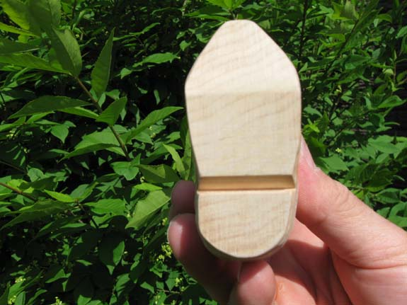
"The Bottom Of the Boot"
I want to make sure that the bottoms of the sole and heel are sanded smooth. I'll be doing a little more work here in the next segment.

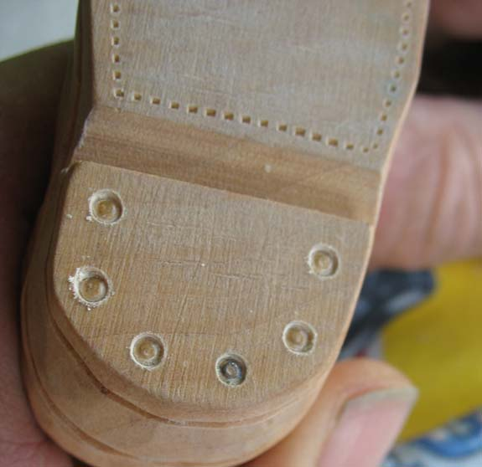
"Stitching and Tacks"
Here I have used a pounce wheel to add stitch marks around the soles. I used a nail set to simulate tacks in the heel.
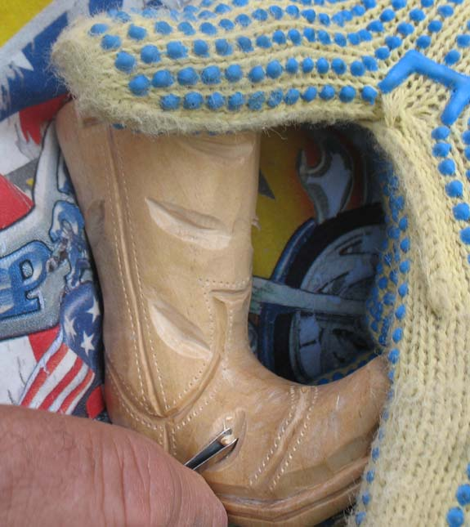
"Wrinkles In The Leather"
Here I have made randum cuts with an gouge and them I use a "V-tool" to make a cut up the middle of each gouge. I just put these marks where I think a wrinkle might be in an old boot.
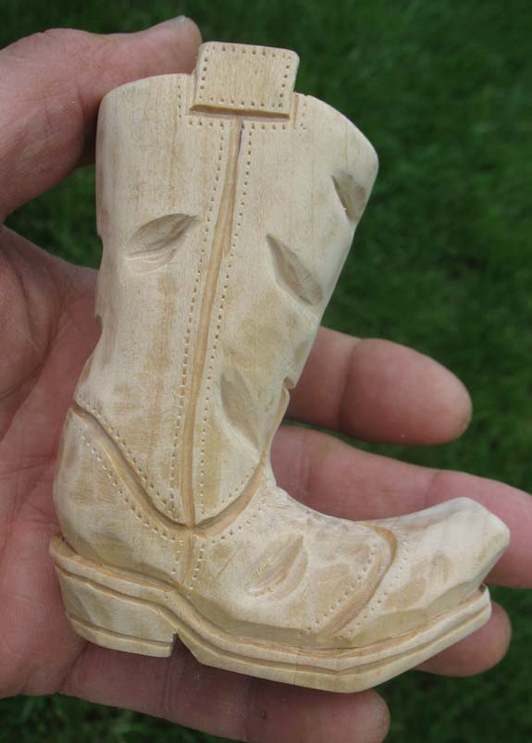
"Finished Sanding"
Here I have finished with the carving and have again sanded the boot all other with fine sandpaper. This also gives a good view of the stitch marks that I added to the upper part of the boot at all the seams.
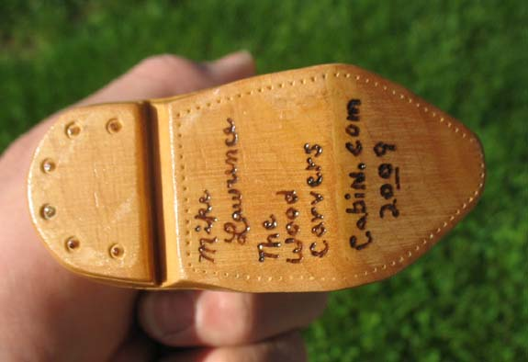
"Signature"
Here I have added my signature and some other wording. Most of the time I just use my initials, "MRL". After adding that I give the boot several coats of laquer. It can be sprayed or applied with a brush sanding lightly between each coat except for the last two coats.
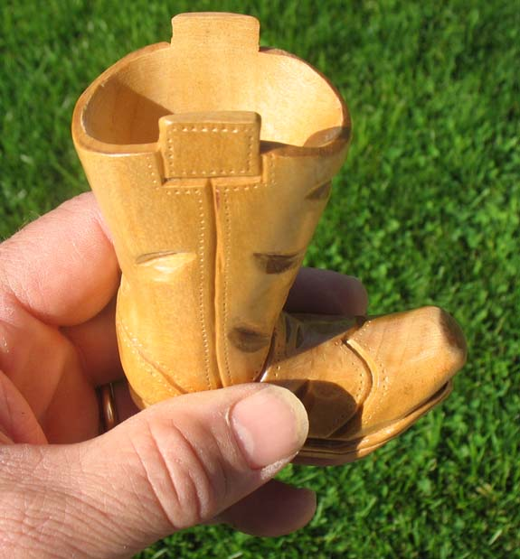
"The Completed Carving"
Here is the completed carving.

